Lowpass Gaussian Filter Kernels
Code:
import cv2
import matplotlib.pyplot as plt
horse_image = cv2.imread("horse.jpg")
if horse_image is None:
exit()
horse_image_rgb = cv2.cvtColor(horse_image, cv2.COLOR_BGR2RGB)
gaussian_filtered_image = cv2.GaussianBlur(horse_image_rgb, (9, 9), 2)
plt.figure(figsize=(12, 6))
plt.subplot(1, 2, 1)
plt.imshow(horse_image_rgb)
plt.axis("off")
plt.subplot(1, 2, 2)
plt.imshow(gaussian_filtered_image)
plt.axis("off")
plt.tight_layout()
plt.show()

Explanation of the Code:
- Image Loading:
  - The image horse.jpg is loaded. If it does not exist, the program exits.
- Color Conversion:
  - The image is converted from BGR to RGB for proper visualization in matplotlib.
- Gaussian Filter Application:
  - A Gaussian Blur is applied using cv2.GaussianBlur with a kernel size of 9×99 \times 99×9 and a standard deviation of 2. This smooths the image by giving more weight to nearby pixels.
- Visualization:
  - The original and Gaussian-filtered images are displayed side-by-side.

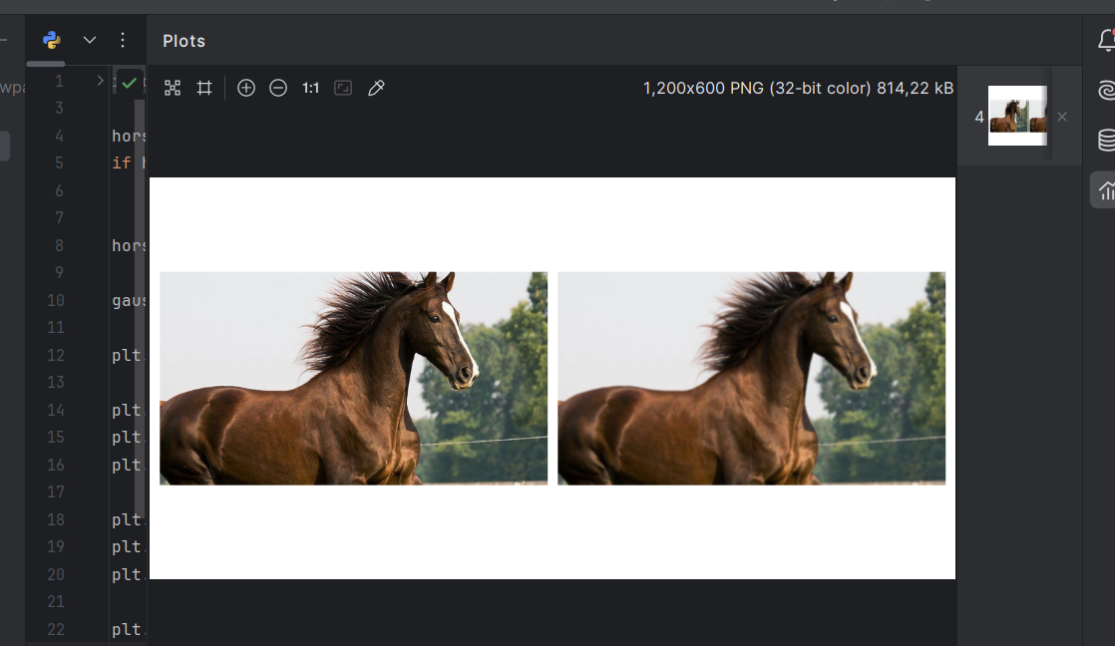
Output:

Report:
Filter Used: Gaussian Lowpass Filter
- Purpose: Reduces high-frequency noise while preserving edges better than a simple average filter.
- Kernel Size: 9×99 \times 99×9 determines the area of influence for smoothing.
- Standard Deviation: Controls the spread of the Gaussian function (set to 2 in this case).
- Results:
  - Original Image: Retains noise and details.
  - Filtered Image: Appears smoother with noise significantly reduced, while major edges are preserved better than with uniform averaging.

